**Explaining the model using What If Tool in GCP**

We try to analyse the data point which is closer to .5 threshold to get a better understanding of model.

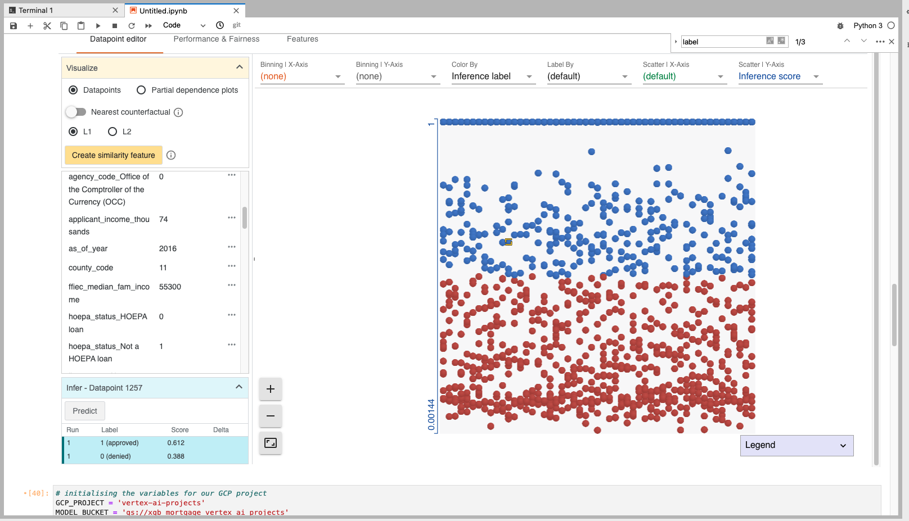

Now we choose a point at the extreme end to analyse which features are actually contributing more to the model.

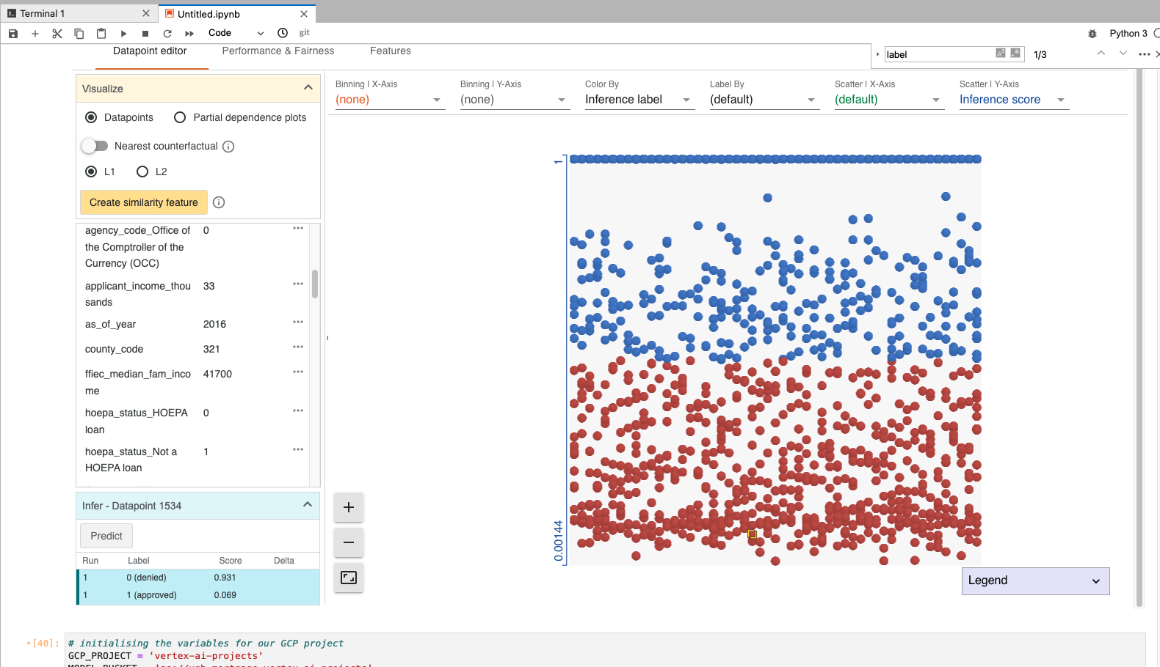

By changing the feature value we observe that there is a 20% change in the prediction probability of the target class indicating that the selected (changed) feature has a huge impact on the model and is important one.

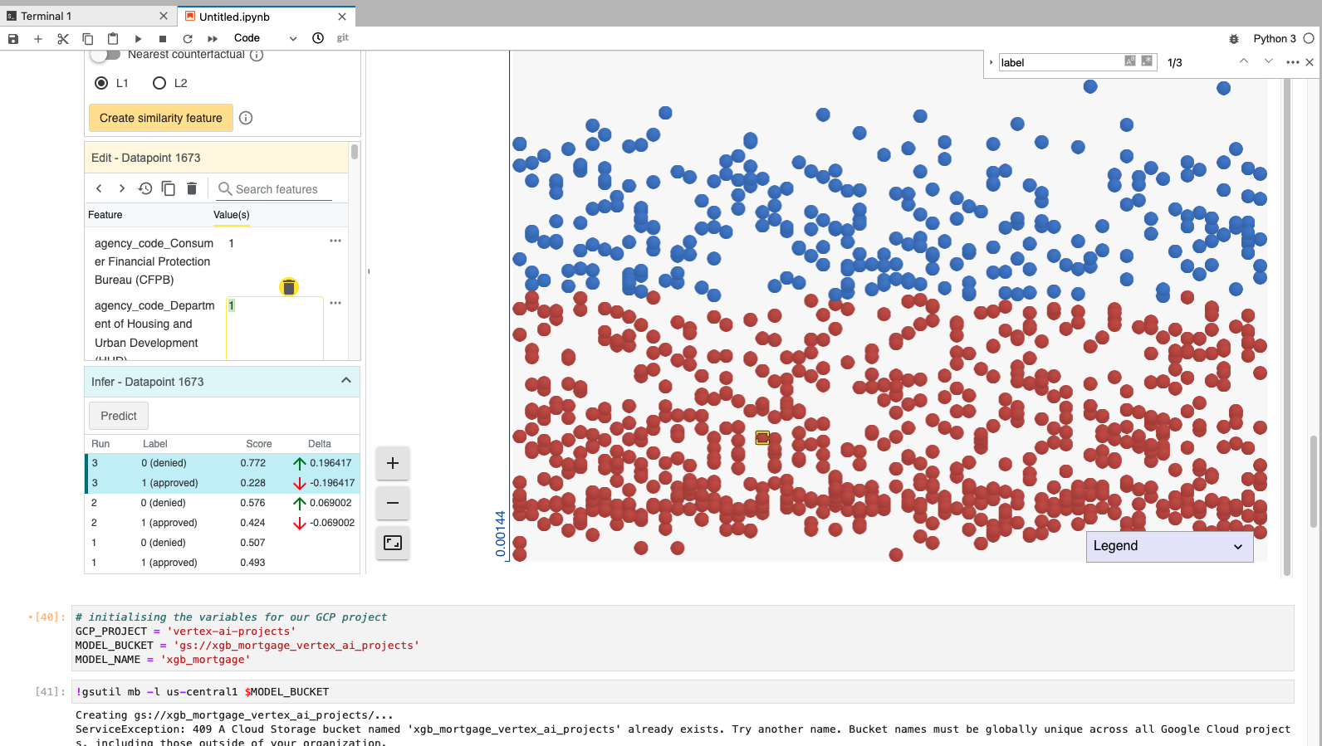

Changing the “applicant_income_thousands” value there is no significant change in the predictions. The delta which refers to the change is just 1.8%.

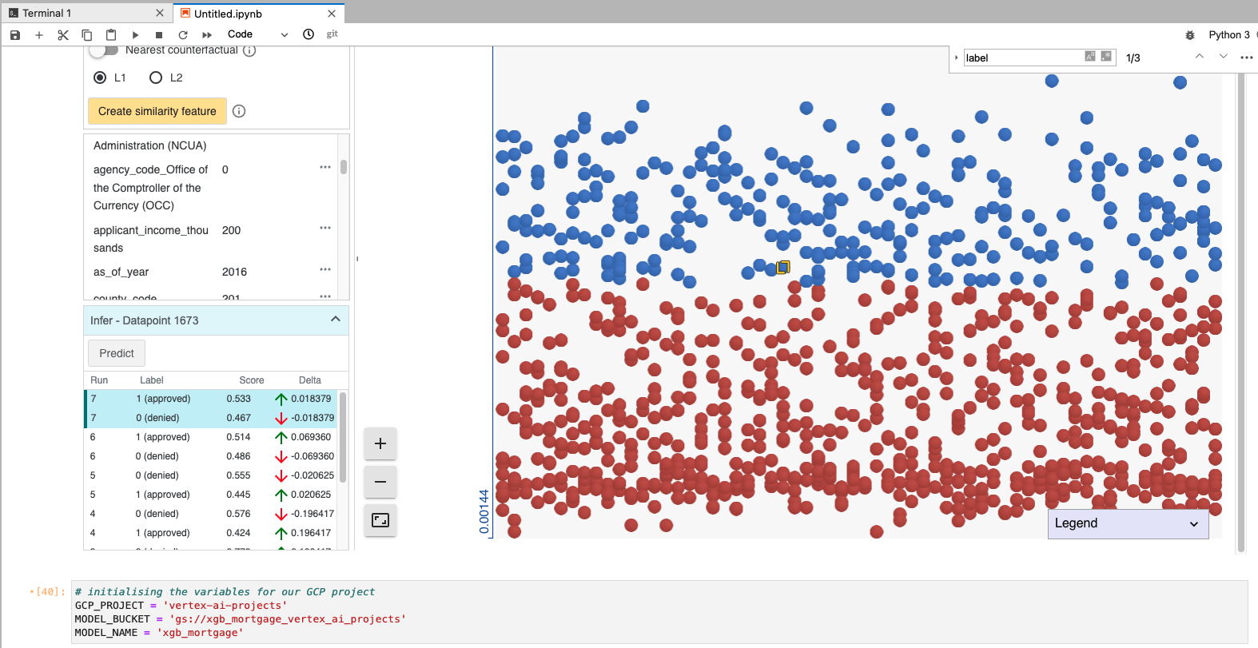

However, by changing the value of “ hoepa_status_hoepa_loan” We observe a change in probability at 43%, indicating it is one of the most contributing factors for the model. Model has given huge importance to this feature column.

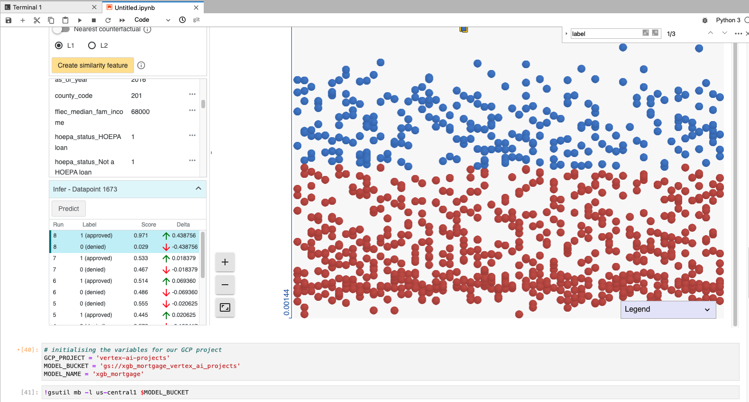

Now we try to find out nearest counterfactual data point w.r.t a single data point, basically data points which have similar feature values.

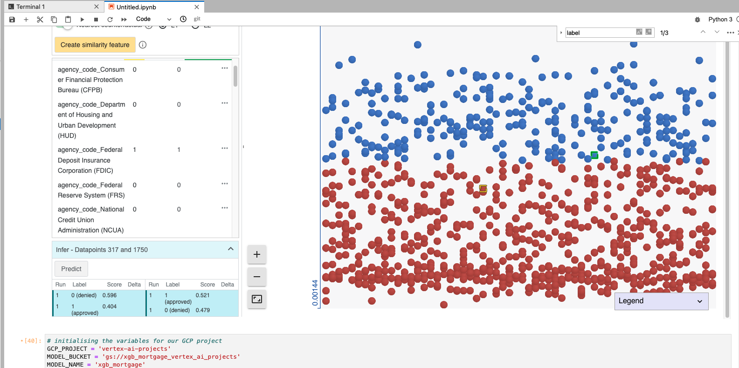

Note that there are 2 data point close to .5 threshold having similar feature values but are predicted in the opposite classes.

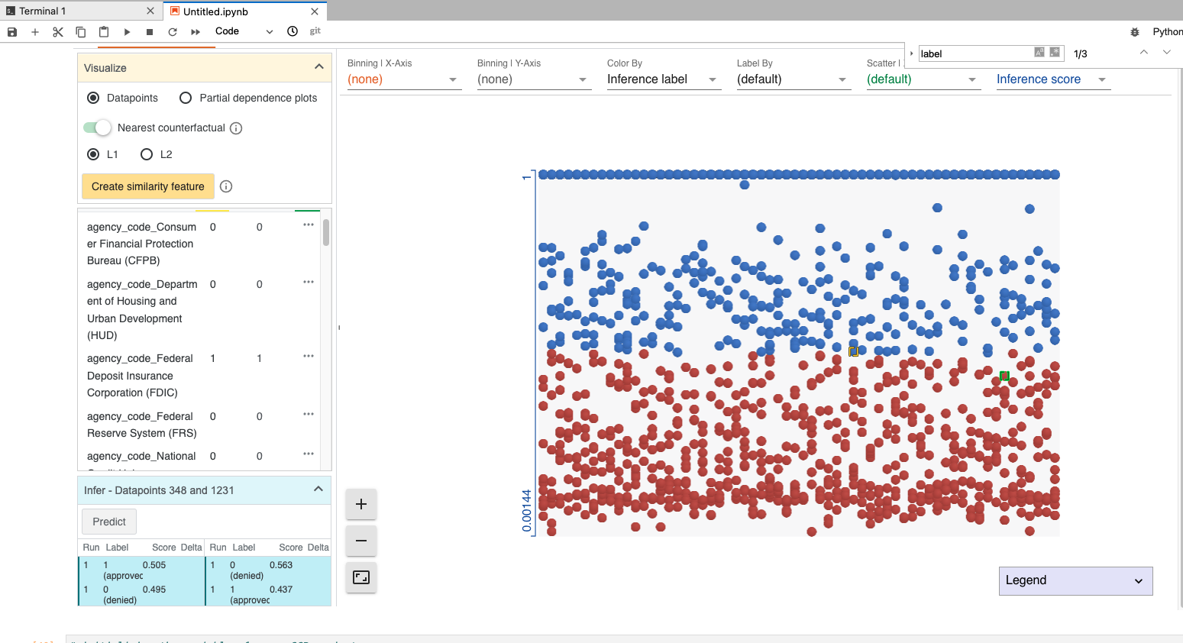

Here we explore the partial dependence plots for various feature columns.  
We observe how each feature affects the model performance.  
  
We notice that higher FAMC tends to lower likelihood of loan be approved.

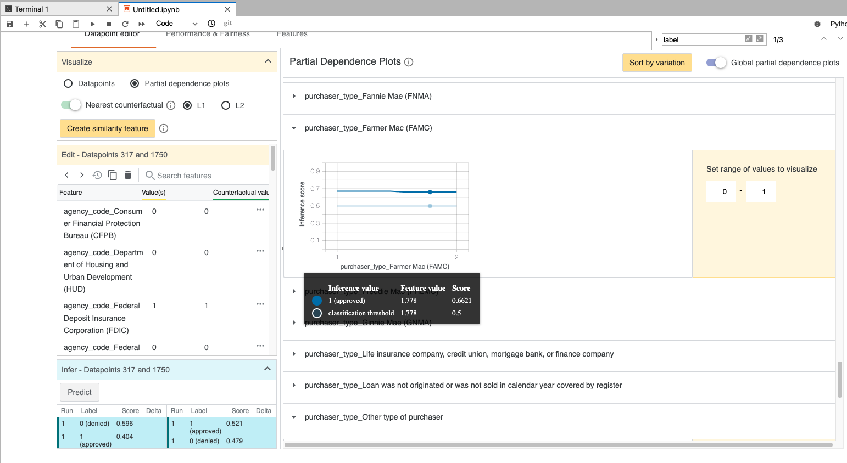

Feature “purchaser_type_other_type_of_purchaser” has little effect on the model decision.

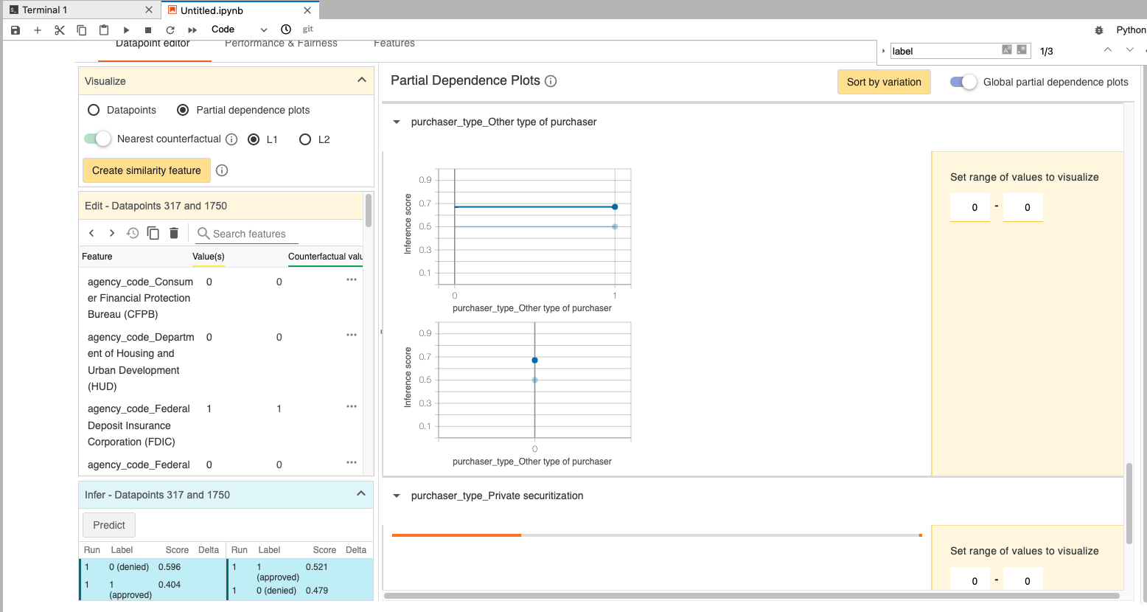

Higher “FDIC” lowers the likelihood of loan being approved.

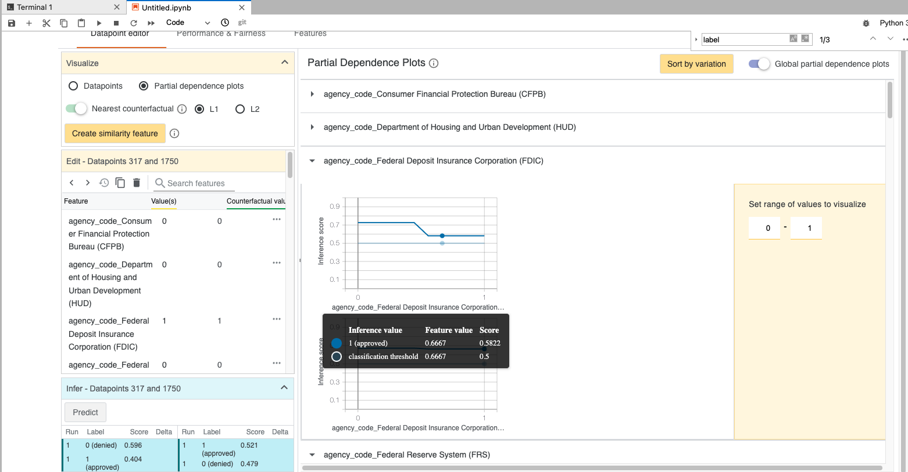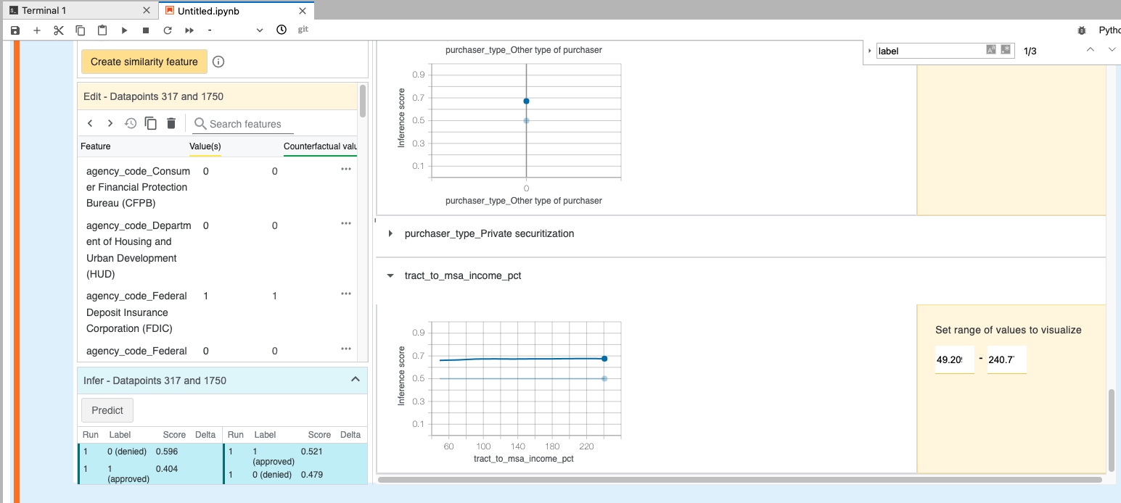

Now we explore the Overall performance and fairness of the model with all the metrics.

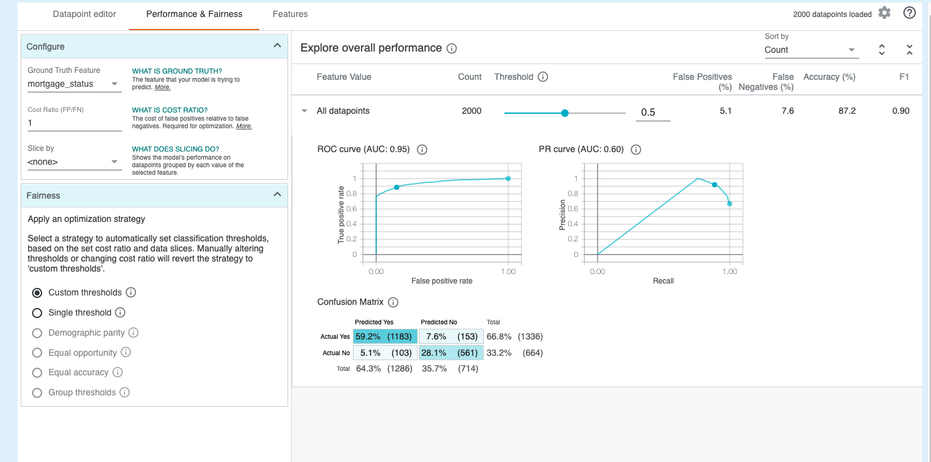

By changing the thresholds we can observe change in the values of metrics.  
Precision and recall change significantly.  
  
Highest precision of 0.82 is obtained at around threshold of 0.62 andrecall at 0.82

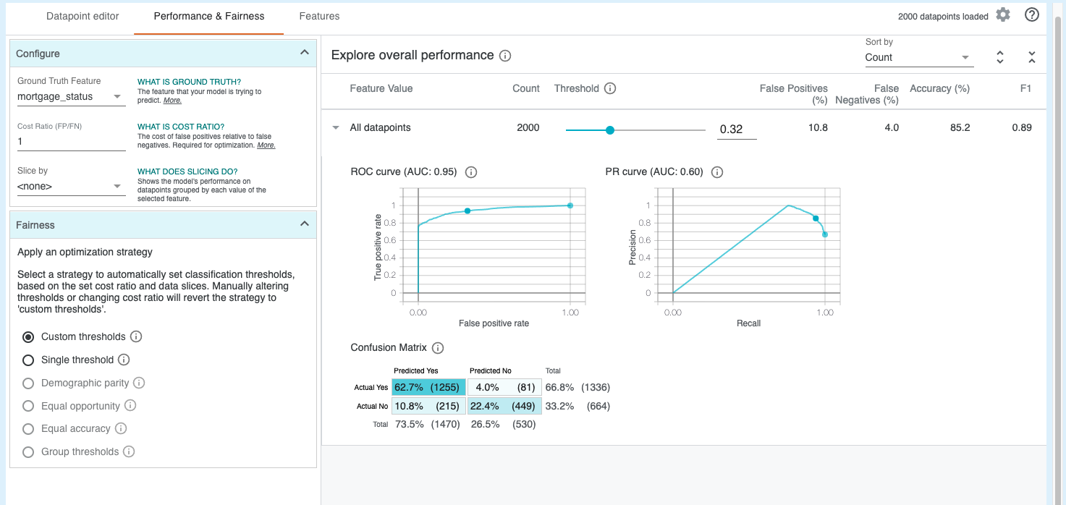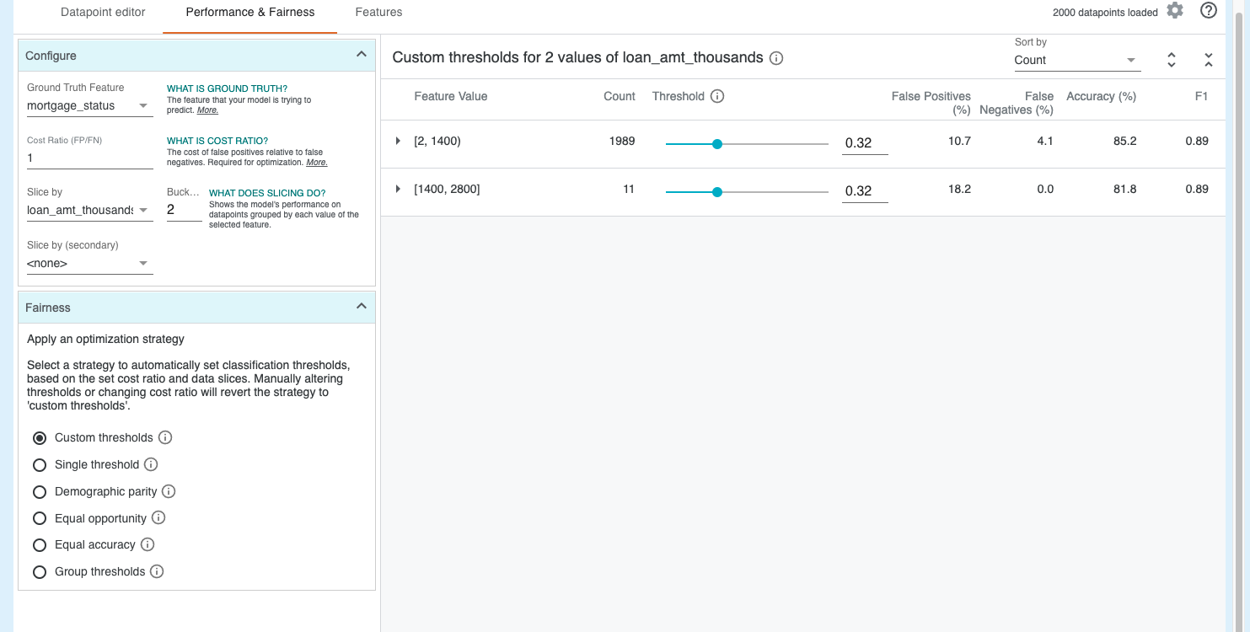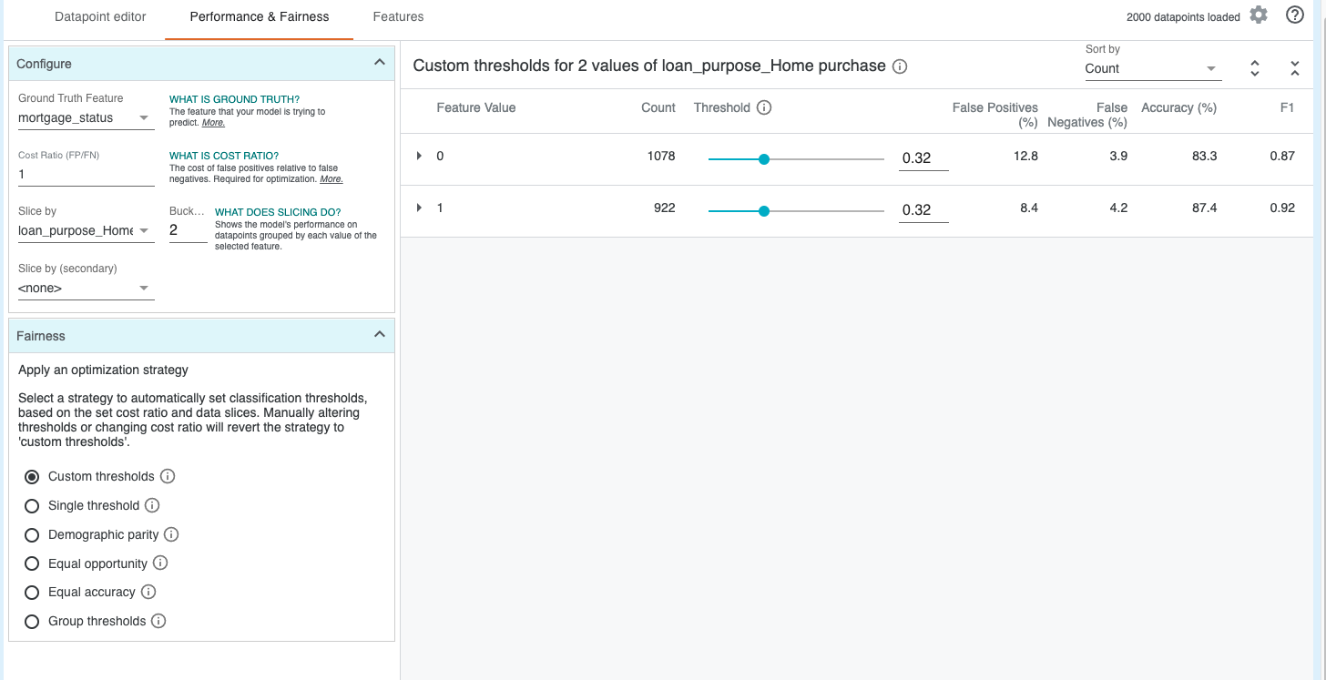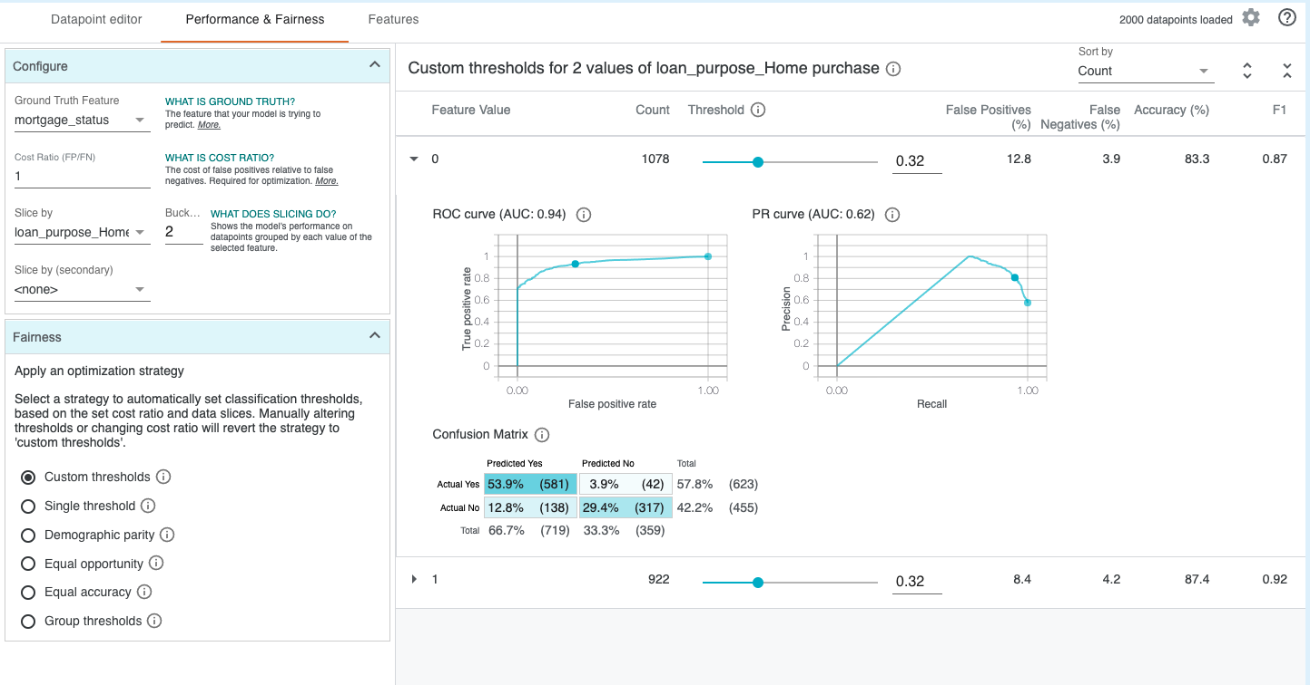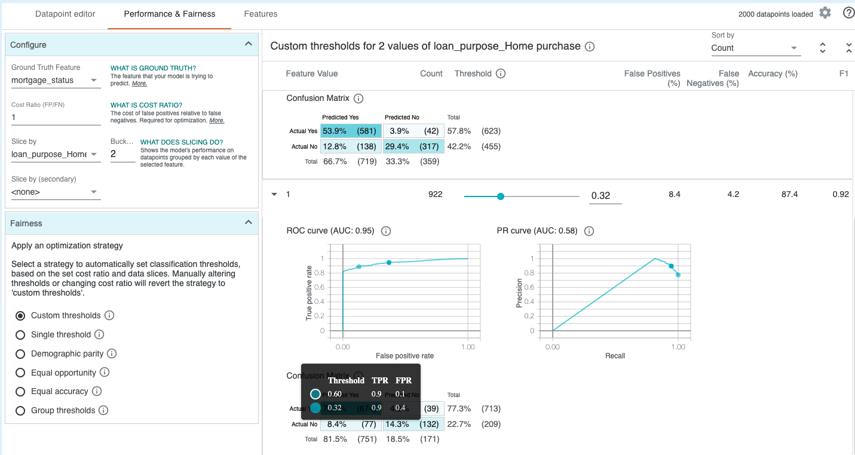

Exploring feature distribution-

This can be used to ensure that the dataaset is balanced.   
We observe that very few loans were approved on the basis of loan_type_conventional, GNMA , loan_purpose_improvement features etc.

